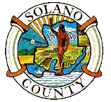
HEALTH AND SOCIAL SERVICES DEPARTMENT
Statement of Fact

I, ________________________________________________________________
living at _______________________________________ City of _____________
State of ________________, declare: ___________________________________
____________________________________________________________________________________________________________________________________________________________________________________________________________________________________________________________________________________________________________________________________________________________________________________________________________________________________________________________________________________________________________________________________________________________________________________________________________________________________________________________________________________________________________________________________________________________________________________________________________________________________________________________________________________________________________________________________________________________

I declare under penalty of perjury that the forgoing is a true and correct statement.

Executed on _______________________, at _____________________, California

_____________________
Signature
_____________________
Typed Name of Declarant
Witness: _____________________

Date: ________________________
48-12-24 (Rev 2/94)

